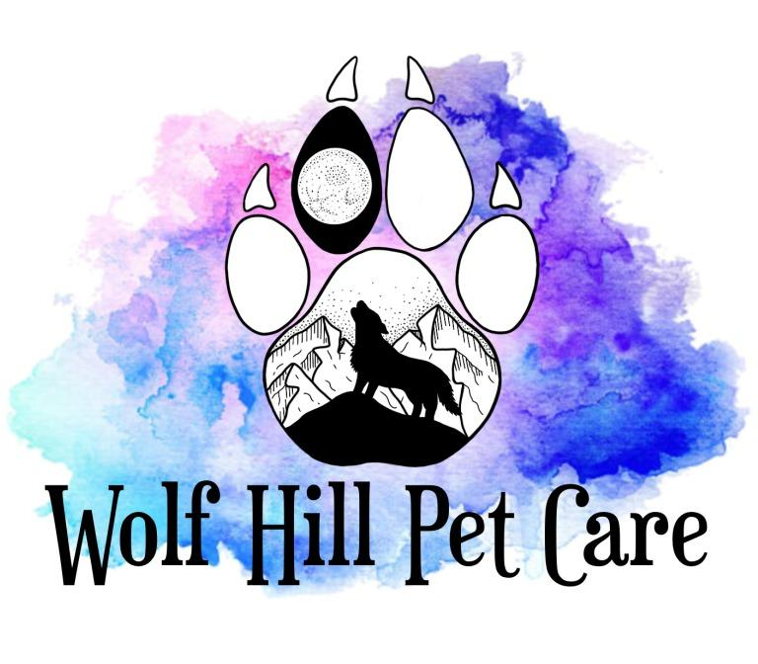

*Services and Pricing*

***Dog Walking Services:***

Dog walking services are customizable to your dogs’ needs, and can include either an on-leash walk around the neighborhood, or play time in your yard.

**$23 / 15 minutes**

**$28 / 30 minutes**

**$38 / 60 minutes**

*\*Households with more than 1 dog will be charged an additional* ***$5 per dog.***

***Dog Adventure Services:***

Your dog will be driven to a local dog friendly trail, park or beach for additional exercise, mental stimulation and socialization. Adventures may be on or off leash, depending on your dog's specific needs and training.

Private Adventures

**$45 / 60 minutes**

**$55 / 90 minutes**

*\*Households with more than 1 dog will be charged an additional* ***$15 per dog.***

Structured Adventures

**$65 / Off Leash Manners Session**

* ~90 minute adventure where your dog will learn recall, impulse control, basic obedience and proper socialization to set them up for success off leash.

**$45 / Dog Camp**

* Structured off leash pack adventure with 4 to 10 dogs.

***Pet Sitting Services:***

We offer pet sitting services to all species including cats, small animals, reptiles and livestock. **Please note that we are not offering overnight care at this time.**

Drop In Visits

Completely customizable to your pets’ needs; Includes feeding, refreshing water, administering medication as needed, scooping litter boxes, bathroom breaks or a short walk, play time and affection.

**$23 / 15 minutes**

**$28 / 30 minutes**

**$38 / 60 minutes**

*-Households with more than 1 pet will be charged an additional* ***$5 per pet.***

Farm Care

We are experienced in caring for many different farm animals, from flocks of chickens to flocks of sheep. We do not care for horses at this time.

***Starting* at $23 per visit**

*\*Price based on time/labor and will be determined at the meet and greet.*